

MICROBUSINESSES IN
THE UK:

RESTAURANTS BARS & CAFÉS

1. IMPORTANCE OF RESTAURANTS, BARS & CAFÉS
In the UK, small food & beverage outlets restaurants, pubs, cafés, and takeaway shops are predominantly microbusinesses with fewer than 10 employees. They represent a significant portion of the hospitality sector and are crucial to local economies.

•Depend heavily on local visibility and immediate customer bookings.
•Google is often the first stop for UK consumers searching for lunch spots, dinner reservations, or coffee shops nearby.
•Movylo Reserve with Google allows these businesses to connect instantly with diners at the exact moment they are looking to book or visit.

2. COST STRUCTURE AND
CHALLENGES UK hospitality microbusinesses face rising operational costs:
•Rent & utilities: Energy bills and rent remain major expenses.
•Staffing: Inflation pushes wages up; many small restaurants have minimal staff.

•Supplies: Food and beverage costs fluctuate due to supply chain issues post-Brexit.
•Marketing & customer acquisition: Budgets are limited, typically 2–6% of annual turnover (£5,000–30,000 for many small restaurants).
Implication: Investing in standalone booking systems or marketing campaigns is often prohibitive. A free tool like Movylo Reserve with Google removes this financial barrier while driving reservations directly.

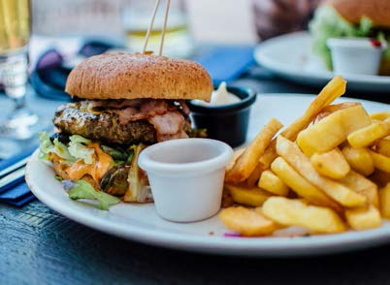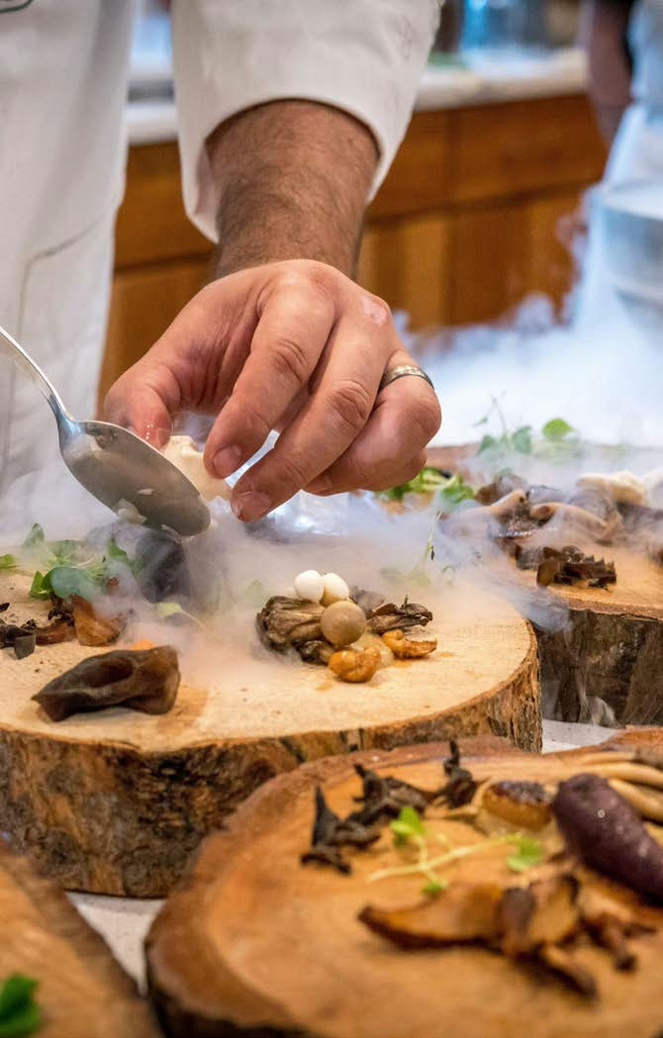

UK MARKETING TRENDS
FOR RESTAURANTS

To stay competitive in 2025, small UK restaurants must:
•Be visible online when diners search for nearby eateries.
•Offer frictionless booking directly on Google without additional apps.

•Track real, measurable results reservations and orders without complex systems.

Why Google matters: The majority of UK consumers start restaurant searches on Google, making integrated bookings essential.

COMMON PROBLEMS FOR
UK RESTAURANTS

- Lack of time to manage marketing campaigns.
- Fragmented platforms: booking software, POS, websites, social media.
- Difficulty tracking return on marketing investment.
- High cost of hiring agencies or developers to manage digital presence.

- WHY MOVYLO RESERVE
WITH GOOGLE FITS RESTAURANTS PERFECTLY
Free: no setup fees or subscription.

•Competitive advantage: Restaurants without Google booking may lose diners to competitors.
•Instant Google visibility: “Reserve” or “Book a Table” buttons appear directly in search results and Maps.
•Seamless for diners: Customers can book immediately, without calling.
•Simple for owners: Reservations are automatically managed by Movylo.

COMPARATIVE COST
ANALYSIS FOR RESTAURANTS

Tool / Service | Cost
Booking system | £15–80
Scheduling software | £20–60
Web developer for integration | £500–1,500 (one-off)
Marketing agency for visibility | £500–2,000

Total potential monthly cost: £600–2,500

Movylo Reserve with Google: FREE, with bookings flowing directly from Google where most diners search.



VALUE PROPOSITION FOR
RESTAURANTS

•Free entry point into online booking and reservations.
•Automated management of bookings without extra staff effort.
•Scalable for small cafés, pubs, or fine-dining restaurants.
•Trusted platform: diners already trust Google, improving conversion.
•Future-ready: businesses can later adopt advanced Movylo features like loyalty programs or promotions.

- STRATEGIC CONCLUSION
Small UK restaurants, cafés,
and bars are constrained by tight budgets, rising operational costs, and limited marketing time.

Traditional booking solutions are expensive and complex.
Movylo Reserve with Google
eliminates these barriers:
- Free, immediate visibility on Google.
- Direct bookings, increasing footfall and revenue.
- Competitive advantage in a crowded local market.
- Result: Restaurants, cafés, and bars can digitize their reservation systems without financial risk, capture customers online, and grow sustainably.

THANK YOU!

